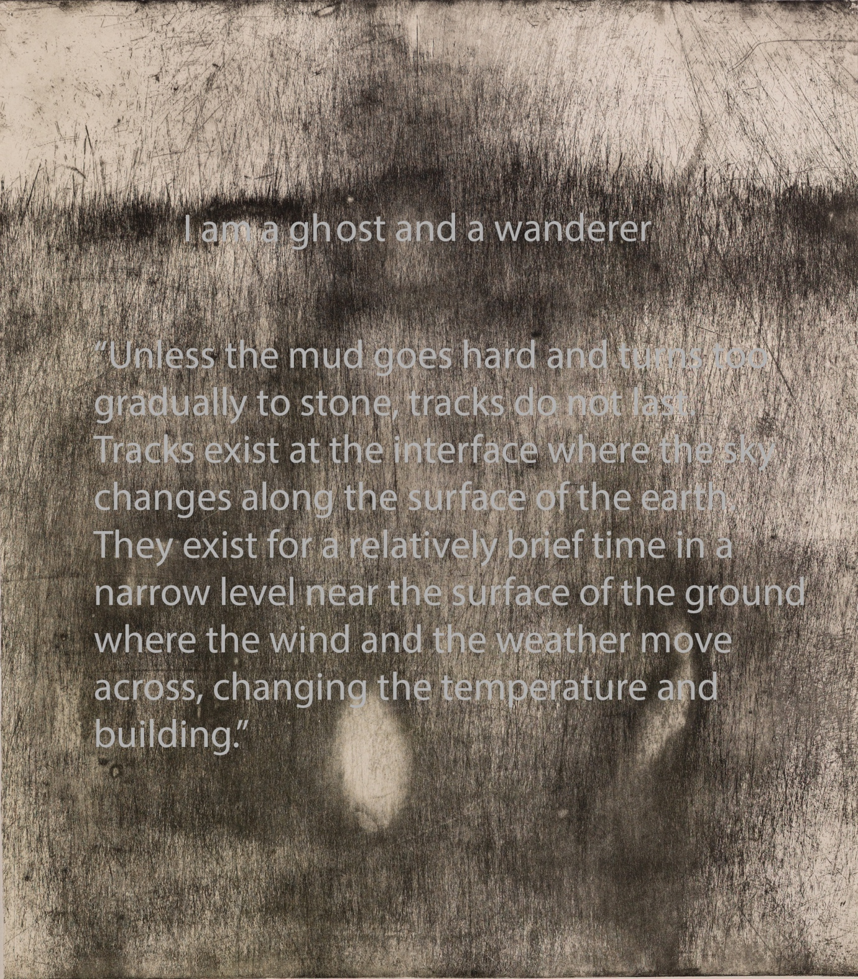

Title I am a ghost and a wanderer
This MFA project has explored the tension, perception, thought and performance found in the art of walking.

Title: I am a Ghost or wanderer
Name: Brendan Cooper
Student number: s3729414
Course: Master of Fine Art (by Coursework)
Completion Date June2026
Academic Advisor Associate Professor Micael Graeve
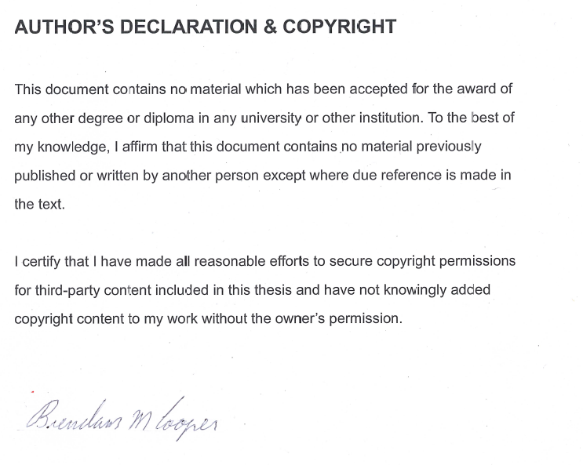
© Brendan cooper
Except as provided in the Copyright Act 1968, this thesis may not be reproduced in any form without the written permission of the author

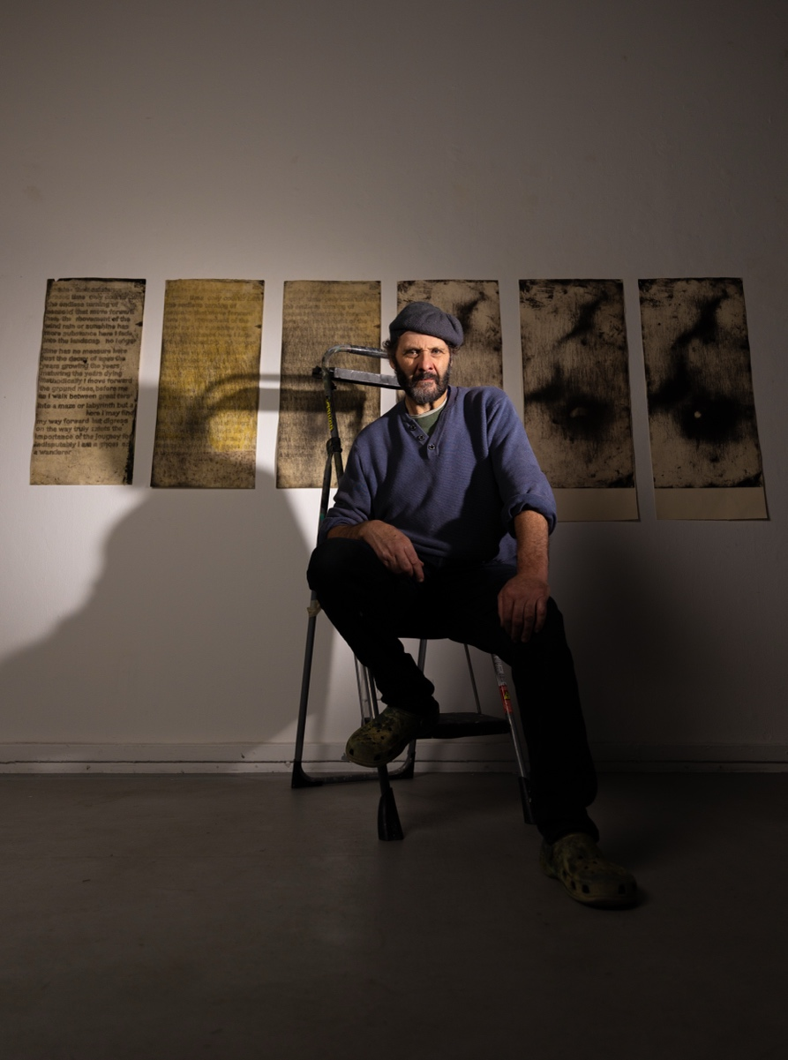

Acknowledgement of AI
I used the writing Help persona in Val (RMIT 2026) to provide feedback on my assignment draft and small paragraphs to improve the writing because of my Dyslexia. Where Val has been used, I have inserted a footnote.

I would like to thank Michael Graeve and Ciaren Begley for their encouragement and help in bringing my exhibition together. For my good friend Jutas pippins conviction that I was able to finish this study and lastly, I would like to thank Marlyn and Petter Haylock for their belief and support in me as an artist.

Research precis

Project Summary
Project Overview
Objectives
Rationale
Key Research Questions
Bibliography

Project summary
“I am a ghost or a wanderer” is a research project that examines perceptions of the city through the practice of walking. Established within a practice-led MFA, it extends and expresses my inner reflections and lexicon through embodied movement and expanded printmaking.
Project Overview
This MFA project addresses and realise my urban journeys though printmaking in an expanded field of artistic practise by combining conventional etching techniques with mark making, typography and psychogeography, this artistic practice-based research offers a personal exploration of the contemporary Australian urban landscape as -- labyrinth and maze, in the broader field of artistic engagements with urbanity. Its concepts and ideas are drawn from rich artistic and academic models that interrogating walking as artistic practice that presents, a strong lexicon that helps build on the theories and ideas of the wayfarer on the map as well as Identifying with the engagement of the flaneur following a repetitive, practice route that is described though prose while use the broad terminology called walking as an art form.

Walking as an art form refers to a body of historical and contemporary practices that raises walking from a mundane or purely functional activity to an artistic gesture. By using one’s own bodies in various ways, artists have, for the most part, replaced traditional materials with embodied movement, producing constructed narratives that question social norms, ideas and collective ways of thinking.

This concept is use though all of my MFA project in many different forms such as using the theory of the maze and the labyrinth as a way to explain the progress of journey, walking repeated routes around the city as a tool to recorded the narrative of the footpath and text that described movement that is situated both in the country and city. This is achieved by dividing the urban and natural landscape into two categories the maze and the labyrinth which functions as metaphors and then an image base conception that describes the urban city as place of confusion, uncertainty and a type of uneasy tension, this idea is linked to the second half of studio 4 I walk therefor I am as a narrative of my walks and then later in my maze made from the copper plate. While in contrast the labyrinth is a place of inward calm this is reflected in my prose from studio 3 Lost in a maze and is what I describe as sustained practice of inward, narrative thinking.

The Labyrinth as a Whole offers only small choices but no distractions while on the journey, this means its path is set before you, a path you must simply follow. There are times where you may have turn back on you goal to get there, sometimes you are farthest when you are closest, and sometimes the only way is the long one. These statements show how meaning and metaphors can be conveyed spatially while giving you freedom in your way forward. The labyrinth is mostly likely shaped as a circle, square or triangle and its main function and design is to direct your journey in wards (often used as a reflective meditation) and even though there are dead ends the conclusion of this journey all most always end in the centre.
In my way of thinking I have assigned the labyrinth to belonging to the natural landscape as there is space and little to no restriction in your path forward and although I have written of particular geometric patterns to the labyrinth, they are in no way constrained to these concepts there are plenty of labyrinths shaped in unusual ways.

You could consider the bush, mountain and forest as a type of labyrinth as to reach the top of a mountain or the centre of a forest you must travel up wards and inwards. Rebeccah Solnit suggests that there is an element of mystery to walking in the natural space she goes on to call this “the Radom, the unscreened “suggesting that you find what you did not know you are looking for, and in doing so you only understand this palace when it surprises you. This is lost in an urban setting where the roads have little to no sidewalks, shopping centres have only carparks and everything has walls and gates the city is designed to accommodate the automobiles both public and private there is no need or desire for walking.

So, by contrast, the maze differs from the Labyrinth as it offers the wanderer multiple choices on many different paths. However, these, must end in a freely chosen dead end, where its walls, stone and concert obstruct the view, causing the person to experience a sense that there is no other way than immediately ahead, trapping the inmate with “false antinomy of freedom and necessity”

With the maze, Walter Benjamin suggests that “the streets names must speak to the urban wanderer like the “snapping of dry twigs” and the small streets in the heart of the city must reflect the time of day… as clearly as a mountain valley”.

The secondary concept within this art project, although less prominent, engages with the idea and context of space and the customary practices associated with it.
This section also reflects on how we define and evaluate these practices, and how
we attribute value to them and in part how we move in and around these
habitations.

Objectives
A: to write prose that inspires feelings of entrapment with in the city, particularly how we navigate our movement within the urban
B: to explore performative move though my body as an Instrument of perception using Methods of respective walking in grid patterns.
C: A collection of prints, and sculptural works that combine to produce evidence of the journey, both literal and metaphorical and to convey my personal perception of a city being a maze and a labyrinth using varies art techniques such as expanded printmaking,

Rationale
t’s a dangerous business stepping out of your front door.
J. R. R. Tolkien, The Hobbit.

This project has explored the tension, perception, thought and performance found in the art of walking. In this task I explored the physical space around
Melbourne and or / urban setting though different ideas and concepts attached to the acted of walking through a space.

This was largely achieved by Introducing expanded printmaking in to the field of urban journeys as a documented research-based project focused on landscape and surfaces; by perceiving the city as a labyrinth or maze though performance walking. To assist with the context and thinking around these ideas I have looked at art projects from several different artist such as Andy Goldsworthy, Tim Ingold, Rebecca Solnit and Brendan Stuart Burns and Mike Collier. These artists have helped to inform and support my multi-layer projects focusses within the theme of the art of walking.

Text-based prose is foundational to my print practice and to this project,
and it remains central to this project for its capacity to articulate the journeys it traces. It offers more nuanced understanding of the prints, particularly in relation to (1) the erosion and loss of time, and (2) the subtle, often uncaptured dimensions of experience. My approach to text-based art has been informed by the practices of Brendan Stuart Burns, Mike Collier, Andy Goldsworthy and Angela Cavalieri whose works critically and poetically engage with these concerns.

Goldsworthy, although often described as a landscape and photographic artist,
frequently explores walking as an artistic practice his art work Goldsworthy’s wall Originally titled “wall that went for a walk” provides a compelling example. My work
walk therefore I am critically using these themes though its methodological and
conceptual framing. It draws substantially on the writings of Collier, and adopts
repetitive walking as a purposeful, designed practice, informed by the site-
responsive and process- based art. Collier like Goldsworthy could be titled as a land artist as his work is distinctly action – based involving the organisation of slow meandering group walks, frequently alongside natural historian Keith Bowy. These walks hover around the urban edgelands, those liminal margins where the urban and the natural intersect and overlap.

However, Burn’s work by contrast is often located at the threshold between abstraction and representation, offering an uneasy tension between the physical and the psychological. This idea is reflected in my studio 3 project sail walk as well in the wondering of the city particularly when one considers the urban as a maze (I walk therefore I am)

For both professional scholars Tim Ingold and Rebekah Solnit, Walking or journeying as an art project has been their focus for quite some time. Rebekah appears to approach her practise from various emotional perspectives. Whereas Tim addresses the problem more for both an anthropological and philosophical point of view. For me both of these approaches are essential to my work as I try to frame the importance of how these concepts help to address the awareness of these spaces. To do this I have used small art projects that involve myself and occasionally my fellow students. These have included short walks in and around the RMIT camps, walking on a long bed of salt along the master’s corridor (building 49) and precise walking routes used to describe the experience of being in such spaces or landscape--spaces that in Melbourne’s case form both a grid and geometric shape.
The salt walk in building 49 was rooted in Tim Ingold as his influences is directly
linked to the philosophical side of this project and often, I quote from Ingold as he
covers these topics However, Solnit s emotional approach is found in the performance- based work that ask my audiences to take part in the enquiry of my art project.

With the main body of work focused on the walk around the city, I had three
questions that needed to be at least partly answered before I could even begin these
walks: How long should the walk be? Where should they start and finish? Why walk
in this particular space?
Once I had determined the placement of the walks, I was able to address the
remaining questions. For example, in the walk titled. I walk therefore I am studio 4; the length of the walk was determined by the route my friend and fellow artist, Justas Pipinis would take to and from RMIT. Once the walk was conceived, the underlying rationale and its significance became apparent. In this case, I was reflecting on his departure from Australia as instance of “things gone that no one sees or captures”.”

“Unless the mud goes hard and turns too gradually to stone, tracks do not last.
Tracks exist at the interface where the sky changes along the surface of the earth.
They exist for a relatively brief time in a narrow level near the surface of the ground
where the wind and the weather move across, changing the temperature and
building

These projects articulate that there is more to this line of questioning --not only in the walking project but also in the text-based art that has been part of my inquires. The prints from the walks are a reflection of the journey, and although they are strong, they do not fully encompass the art project, some text is also needed. The text-based art is important to the full understanding of my project.

For example, Rebecca writes that when you give yourself to places, they give you yourself back, the more one comes to know them the more one seeds them with the invisible crop of memories and associations.
If I am to include the text as the catalyst to my printing work, I need to document how the spaces I walk in shape the prose. Unlike the previous questions, it is feeling, thoughts and the interplay between past and present that guide and direct the writing.

Sometime there is a bias attached to the space in which I am walking, however this does not necessarily have to influence the prose. However, the statement I walk therefore I am in this case has directed connections to many of the quotation, contexts and references within this project. A significant section of the text therefore explores ideas of memory, wandering and traces, enabling me to draw on these themes explicitly and critically within my prose.”

Research questions
In what ways can expanded printmaking capture and trace the performance of walking in the city, revealing/ expressing my embodied experience of the city as a
labyrinth and maze.

“In what ways can walking be conceptualised and contextualised as an art form in urban environments, and how can this be explored through visual practices?”

In what ways can prose, as a text- based form, be used to interpret how I perceive my surrounding environment within the urban landscape?

Methodology

This methodology follows the evolving narrative, conceptual refinement, and critical investigation of walking as an artistic practice over the course of the MFA. It also documents each individual project, attending to the investigation in which these projects have shaped, informed, integrated and extended one another.

Concepts and ideas
Progressing from Honours project into The Master of Fine Art was a logical step, as my art project still has considerable scope to develop and mature, both conceptually and materially. It had become clear that the project was not resolved I had much more to articulate about walking as an art form, and the application of my methods of visual representation required further refinement. Although the artistic methods I selected were conceptually rigorous, there communication was not fully understood without the support of didactic text.

My interest in walking as an art form was initially inspired by Tim Ingold’s book Lines: A brief History, in which he compares different perceptions of the line and examines how it manifests across practices of making and doing.” Like Ingold I use the practice of making as a way to understand the process of my project while trying to make sense of the many different of practices that have informed my work.

Essentially the different art projects I have worked on over this MFA programs were inquiries as to the best ways to convey theories that are visually constructed results of the city as a labyrinth and maze, the narratives and traces of the footpath and the documentation of this though artist books as I take journeys around the city, while considering how these spaces affect us socially with in the field of expanded printmaking.
“The field of expanded printmaking is a diverse discipline in which the practising printmaker continues to engage with key printmaking methods such as relief, etching, lithography and screen printing. However, these traditional techniques are extended through the incorporation of other artistic disciplines, including paper sculpture, artists’ books and digital media, within a major project. This practical exploration is supported by a written research component that situates the practitioner’s work within contemporary discourse.”

Studio 1 Frustration and realization, a step forward in the right path.
As briefly stated in the previous paragraph the question of how to present conceptual art with minimal accompanying information, while still communicating meaning to the viewer, has continued to challenge me. My intention has been for my prints to convey the different walks I have taken in both rural environments (studios 1) and the city (studios 2, 3 and 4). However, I have observed that, without written information and/or a clear visual entry point, the meaning of my work can be obscured. While this uncertainty and vagueness is not inherently problematic, it can make the work more difficult to interpret.
However, I do not find this realisation discouraging; rather, it marks a productive starting point and motivates me to refine both my making and my conceptual approach to how to convey a meaning though predominately abstract print. Although many artists hope their work will be understood, there will always be limits to interpretation, often due to factors such as limited prior knowledge or visual literacy. In such cases, the viewer is not at fault; it is only reasonable to expect that they may grasp only part of what the artist seeks to communicate. At best they grasp at meaning in the work like wisps of fog in the morning light.

In Studio! 1 revisited an old idea from my Honors project that focused on repetitive narrative though “The Journey”. In that earlier project, I asked serval students carry an A5 copper plate with them between home and the university. After each plate was returned, I printed it and then gave it back the student. This process continued over approximately two weeks, during which I repeatedly re-etched each plate, producing multiple variation of the image.
Predominantly this project was based on another student’s journey rather than my own and although relevant to some of my conceptual idea I felt it was losing the connection of myself with in this art project. So instead of giving the plate to another student, I decided to strap a plate to my own foot and walk, allowing my movement to generate the marks. This approach produced a number of strong images; however, the concept had practical restrictions, particularly the difficulty of securely attaching the plates to my feet. After a week, I abandoned this method and began exploring alternative ways of capturing the narrative of the footpath through different approaches not just in the discipline of printmaking.

Studio 2 Journey, traces and eraser

“The use of salt, as mentioned in the Rationale, emerged for me as the next project because of its relationship to the body; as humans, we require. salt to live. Historically, salt has travelled across immense distances and held immense value, and this lineage of movement and exchange resonated with my interest in Journeys and their traces.

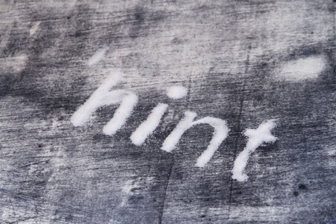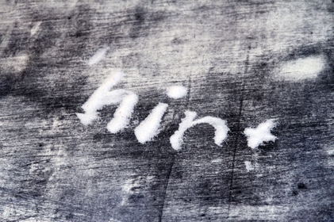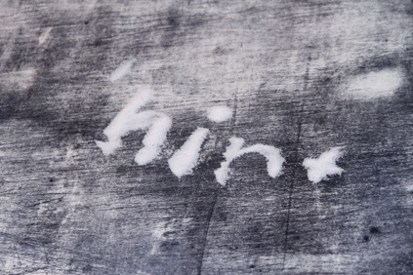

However, in a brief experiment (studio1), where I formed salt into words associated with movement, travel and erasure, the work felt unresolved and somewhat clumsy.” The concept proved untenable in practice, as it introduced many logistical difficulties and imposed a level of authorial intrusion that contested the parameters I had set for the project. As my practice is structured around self-imposed limitations that prioritise process and material agency- or what I refer to as ‘alchemy ‘over overt aesthetic control. In this framework (project), my role is primarily that of an architect or director of inquiry rather than a traditional maker.

For instance, in an earlier experiment, using my moment mainly as a means for activating the process, while understanding the artwork as arising from the interaction between the copper plates and the footpath.
So, in response to this small project, I restructured the art enquire on the subject of salt as an installation. This format better aligned with my conceptual interest in the traces of a journey and their subsequent erasure. I realised I need to create a temporal surface – one that could register, hold and then lose the mark of moment over time. This surface needed to capture, record, and then erase the evidence of the journeys performed by myself and the other students over the course of a week.

The requirement for a temporal surface was decisive to remaining conceptually honest if the surface were fixed or permanent, the work would simply function as a recording device, weakening its transient process-based quality. The decision to use salt as the primary surface material was therefore both practical and deliberate: its granular instability allowed the surface to be swept clean each night, imbuing the work with an ethereal, ephemeral character while grounding it firmly in the histories and bodily associations of the material itself

Overall, the project was largely successful. The core idea remained legible, though at times there where suggestion from other students that the use of the salt risked distracting from the underlying conceptual framework. This however may be conceived as I falsehood as I received mix reaction to the understanding of salt and why I used it as the temporal surface. Nonetheless, I am confident that the amount of information available on the journeys of salt should have been adequate to their understanding. In this case that the work ultimately articulated its concerns with presence, trace and erasure effectively.

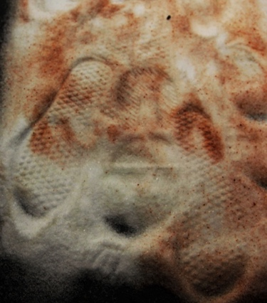 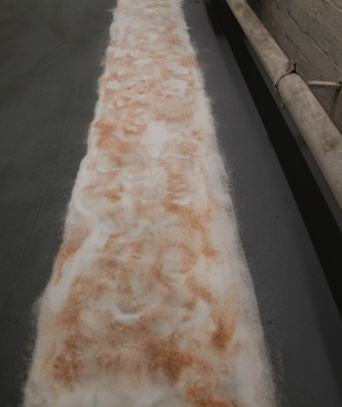 Pink Himalayan salt 3 meters by 1 meter
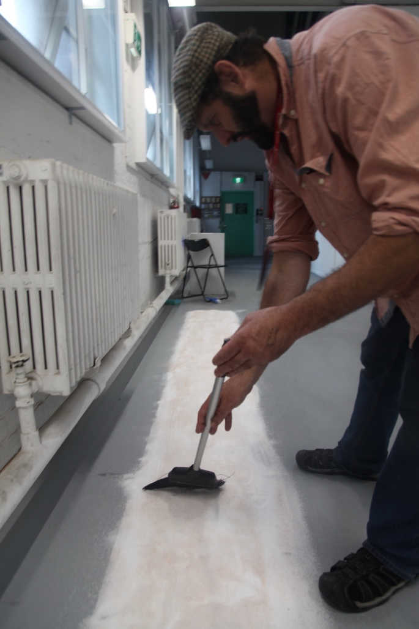

Studio 3 I walk there for I am

Studio3, my initial intention was to continue working with information derived from the previous project. However, I came to recognise that I had pursued the salt- based concepted as far as was productive for the time being.

So, a new medium was required—one that could still engage with the conceptual material and ideas developed earlier from the salt walk but on a larger and more expansive scale appropriate to this master project. To address this, I returned to research question 2 “In what ways can walking be conceptualised and contextualised as an art form in urban locations, and how can this be explored through visual practices?” as well as this question I then ask myself what discipline might best underline this idea and how can I visually present it.

I arrived at a clearer direction for my project while reading Lines a Brief History written by Tim Ingold’s.
Ingold verbalizes that we should imagine ourselves as a wayfaring—a model of movement in which the path is primary – and more destination- driven from of travel. He traces the lineage of the line through quotidian practices such a walking, weaving, storytelling, and drawing arguing that these activities are united by their linear unfolding. Ingold also introduces the concept of the reductive and additive line, theorising that most lines can be situated within one of these two modes. This theoretical view prompted me to reconsider works such as Michelangelo Pistoleetto Walking Sculpture and Richards A Line Made by walking. In dialogue with these precedents, it becomes evident that walking was not merely a theme in my project but becoming its primary method. So how might I formalise this act of walking and how could I collect and articulate the narratives residing in the surfaces of the footpaths I traverse? The resolution came through an engagement with printmaking, particularly copper etching, which offered a means to inscribe the movement into a material record.

Drawing on the practices of Richard Long and Michelangelo Pistoleetto, and revesting an earlier proposal to strap copper pates to my feet and walk, I redeveloped the project around the idea of taking a single plate for a walk. A large copper plate, sealed with bitumen, was repeatedly carried through the same urban routes. After each walk, the plate was re-etched and printed, then. Re-coated, so that lingering marks from previous states persisted only as ghostlike traces beneath the surface. In this iteration, the work functioned as an extended inquiry into the progressive erasure of narrative content, examining how far meaning could be diminished while remaining tethered to the discipline of one plate.
The resulting series was marked by a pronounced visual and material richness. It can be argued that I have translated the narrative of the footpath into a contemporary visual language. As Rebecca Solnit suggests, “the motions of the mind cannot be traced, but those of the feet can,” my work seeks to visualise this relationship between walking, thinking and the paths we inscribe on the urban landscape.
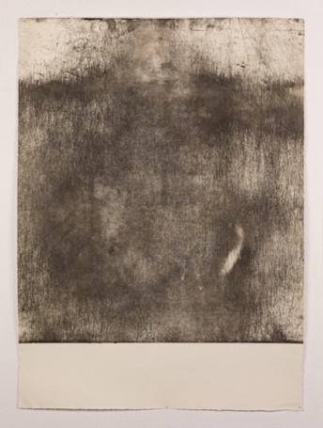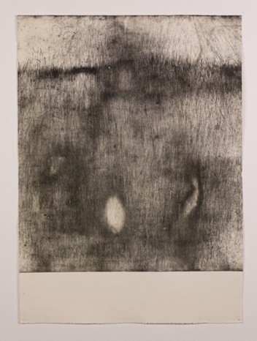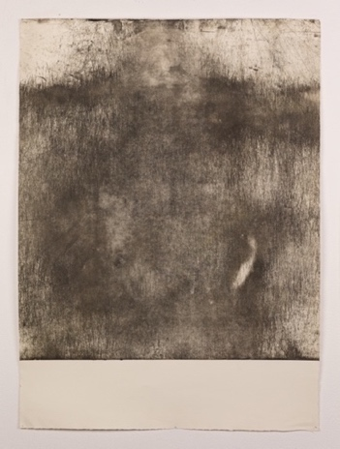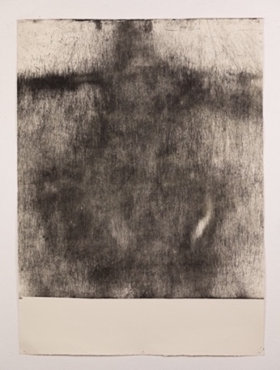
Brendan Cooper I” I walk Therefore I am “studio 3 2026 Hahnemuhle printmaking paper 300gsm 1 to 4 prints size 1006 mm by 775 mm

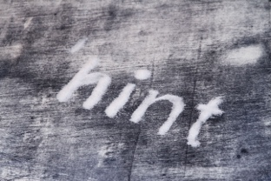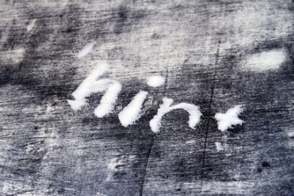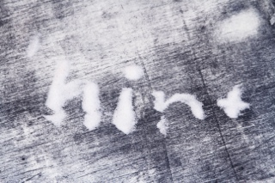
Brendan Cooper NT 2020 Salt NO size available
At this stage I decided to use the earlier salt text into a dialogue with the new prints, situating the recent work in relation to the pre-existing salt words. Audience responses, however revealed a structural incoherence between the two components that seemed to inhibit a fully cohesive reading of the art project.

On the floor, the salt words assumed visual dominance and consequently diverted attention from the prints. This imbalance made visible an unresolved tension between object and environment and indicates that many viewers did not register the installation as a cohesive spatial field.

Studio 3 (B) Lost in a maze

This response made it difficult to identify a clear way forward. As noted earlier, I was attempting to engage with text as an entry point, and although prose was the form I initially intended to work with, I was still exploring other approaches. One of these involved considering text as image, as exemplified in the work of Angela Cavalieri.

Angela Cavalieri is a printmaking-based artist who transforms text into image, giving the written word a visual existence. As in my own practice, travel fortifies her exploration of language. Before she visited Italy, particularly Rome, she had already travelled extensively in her imagination, as a child. Moving through village and city streets as visual map created by the stories of her family. Rebcca Solnit suggests in here book Wander Lust ------

“The rhythm of walking generates a kind of rhyme of thinking, and the passage through a landscape echo or stimulates the passage through a series of thoughts. This creates an odd consonance between internal and external passage one suggests that the mind is also a landscape of sorts and that walking is one way to traverse it.”

Over time I too have cultivated a sustained practice of inward, narrative thinking—a kind of ongoing internal story-making that has gradually found its way into prose.
The resulting writing is marked by a sense of motion: ideas that shift fluidly from one perception to the next, rarely remaining fixed on a single topic for any extended period. So, within the salt- based text works, I was searching for an entry point, a way for written language to fold into visual form. This exploration simultaneously signalled an attempt to extend my practice beyond the parameters of printmaking

As once more I could not discern a clear reading within this art project, and with no more ideas other than text in the form of printmaking I decided that printing was a way to present the text as image, as a textual strategy, but not so much restricted to a traditional way. For this next project I would choice a more contemporary approach to printmaking (an expanded form of printing) focusing specifically with open-bite etching on copper plates. This new art project was achieved through the use of a Posca pen as the method of writing on the copper plate. And as with all etching practices, the text had to be written backward, both with the sentences and also in the lettering of each word, which needs much concentration making the project difficult. With this form been use it enabled my prose to maintain a sense of motion in both its written and physical forms. The result I was looking for was prints that were a balance readable prose with a material surface that evokes concrete or bitumen, retaining a sense of roughness and resistance.

Now while the new text-based print did generate motion in the act of reading the prose, the layout remained visually static; movement is contained within the sentences rather than distributed across the surface. What I was pursuing is visual movement—a legible record of abrasion, erasure, and loss scored into the skin of the footpath.

So, I repeated the strategy of taking the new (text-based copper plate) for two walks, pushing further the process developed in my prior work. This method clarified earlier issues of readability and generated a more coherent project. The text-based prints that emerged from this process convey abrasion, erasure, and loss, concluding the project with works that record the moment both in the texture of the language and in the marked surface of the paper.
Open bite etching operates by surrounding large sections of the plate to the acid without the mediation of aquatint or ground instead of discrete lines, the metal yields shallow, open depressions- soft planes, rough craters, ambiguous surfaces. When inked, these zones do not read as sold black; they print as light, mottled expanses, their edges darkening where ink collects in the etched rims.

As a result, open bite is particularly effective for creating broad. Textured fields; back grounds that carry a quite visual noise and support, rather than compete with, the more articulated marks elsewhere on the plate such as text.

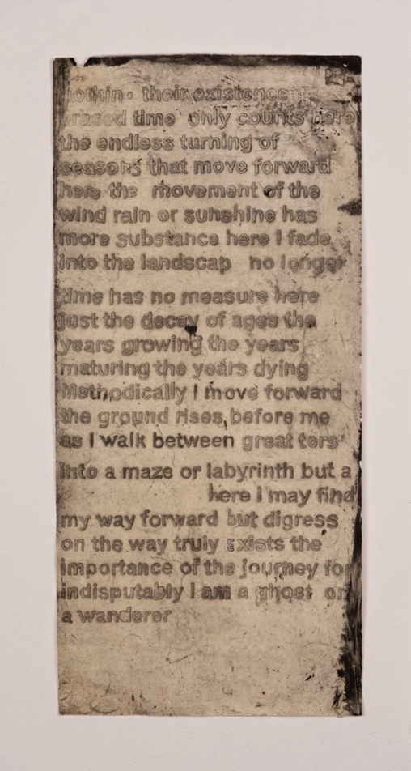 First print Brendan Cooper NT 2026 ‘Hahnemuhle printmaking paper 300gsm size 880mm by 410 mm

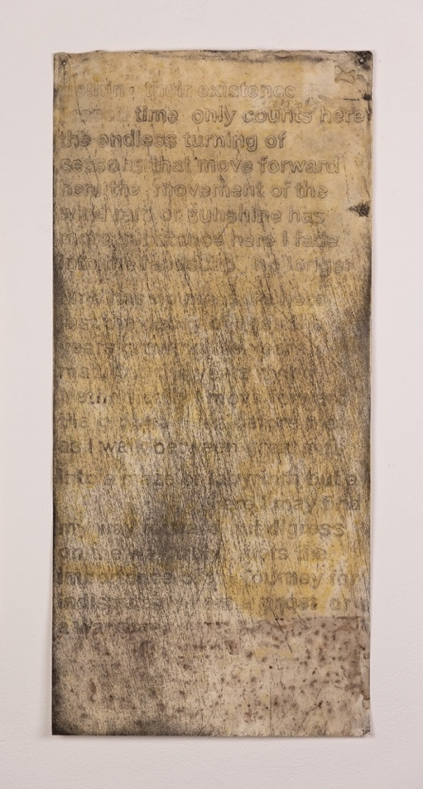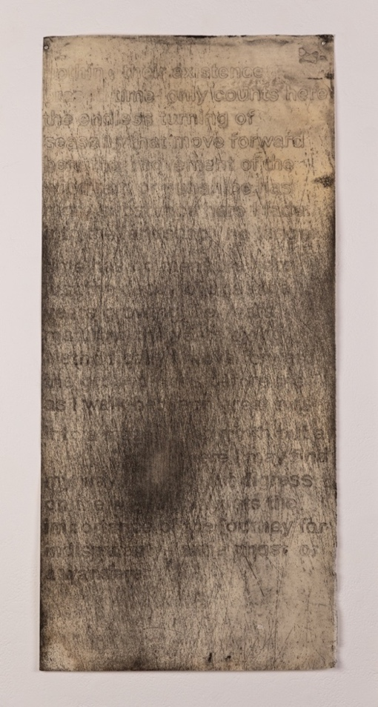

Second print Walk 1 Third print Walk 2

Brendan Cooper NT 2026 Hahnemuhle printmaking paper 300gsm
Size 880 mm by 410 mm

Another potential point of entry I was considering is the discipline of artist books, which may offer a productive context for bringing these strands together, given that the book form inherently implies text and or narrative. At this stage I had begun to consider my idea of artist books I wanted a way of recording the walk undertaken for this project in text yet retaining it form as an image as well. After some thought I created two book one large for recording the walk I had done in studio 4 and a smaller book as an instruction guide for anyone who would want to experience the way I created Studio 3,4 (Lost in a Maze and I walk therefore I am). 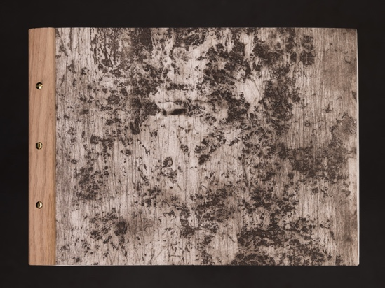 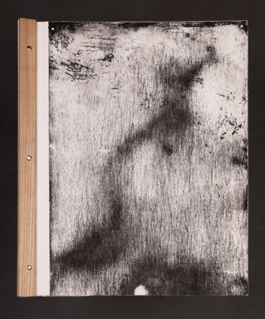 Brendan Cooper Studio 4 Walks 2026 Hahnemuhle printmaking paper 300gsm large book 60cm by 50cm small book 32cm by 45cm
At this stage, the final research question remained the only one I had not yet explored, either practically or in written form, within my RD. One last series of walks was also yet to be completed. This series, briefly introduced in the Rationale as a framing device for the main body of the project and titled “I Walk therefore I am “was crucial to addressing the final research question:
“In what ways can expanded printmaking capture and trace the performance of walking in the city, revealing or expressing my embodied experience of the city as a labyrinth and/or maze? “
While preparing for this series, I encountered a passage describing Tony Smith’s journey, in which he questions whether the road and much of the surrounding landscape were artificial and, if so, whether they could be considered art. This line of questioning goes directly to the heart of the issue concerning the aesthetic status of the footpath and/or road. Can a road or pathway be regarded as art and, if so, in what sense?
For me, the answer was unequivocal. In the new work I was about to explore, I treated the road—the site upon which crossing occurs—as the crucial medium that constitutes it as art. This understanding became the catalyst for my subsequent project and conferred authenticity upon it. However, due to time and material constraints, I could only research this newly expressed concept on a reduced scale, both in terms of the copper plate and by limiting the number of walks undertaken for this enquiry as I was eager to move on to the concluding project and needed to cut the copper plate.

I walk There for I AM (studio 4). has its roots in works such as Michelangelo Pistoletto” s “Walking Sculptor”, in which his practice sought to free art from the constraints of the art market and its perceived corporatisation. It also draws on Francis Alys” s “Sometime Making Something Leads to Nothing”., an art project that wrestles with minimalism through a kind of erasure.

Both of these conceptions are central to my own inquiry. Another key influence is Richards Long’s ‘A Line Made by Walking” Long simply walked back and forth along a strip of grass until a visible line was formed. Like Pistoletto’s attempt to remove market restraints and corporate structures, Long’s work opens a space to consider the additive and reductive nature of the line. This tension between addition and subtraction is fundamental to printmaking and it underpins my enquiries in studio 3 and 4, where I quite literally “take the copper Plate for a walk”

studio 4 (B) “I walk there for I am “

While studio 4 appears closely related to studio 3, in regard to using a copper plate and taking it on mutable walks the conceptual inquiry is significantly richer and cannot be read simply as an extension of the earlier work. Studio3 more directly echoes Richard Long’s “A line made from walking” especially in its emphasis on additive and subtractive gestures and the operation of erasure. Studio 4, however, reorients the practice towards tracing, erasure, departure, mapping and thought. For one can only think (mediate when you are walking.). If you stop then you cease to think or as jean- Jacques Rousseau remarks in his confessions, “my mind only works with my legs”. As articulated in the rationale, this walking project is anchored in my friend’s departure from Australia, which infuses the inquiry with a personal and affective dimension.
“Unless the mud goes hard and turns too gradually to stone, tracks do not last. Tracks exist at the interface where the sky changes along the surface of the earth. They exist for a relatively brief time in a narrow level near the surface of the ground where the wind and the weather move across, changing the temperature and building

From the inception of this project, which seeks to trace my friend’s walk, it was clear that there was no straightforward visual strategy to demonstrate that he has traversed the four routes along which I pulled the cooper plates. This absence of directed evidence, as Tim Ingold’s writing implies, becomes central to the work’s aesthetic appeal: a subtle residue of his presence, intensified though an expanded printmaking methodology.
By employing mapping and copper etching, I translate his time in Melbourne into a series of material inscriptions. In walking these routes, the project aligns with Ingold’s assertion cited above, and it is this condition that underpins the work’s aesthetic force: I have, in effect, transformed mud into stone.

The completion of “I walk therefore I am” produced a series of three etching prints each one bearing deeper marks of wear. With every pull, the copper plates break down a little further, its surface slowly eroding and transferring that degradation to the page- a visual trace of movement, like the residue of footprints.

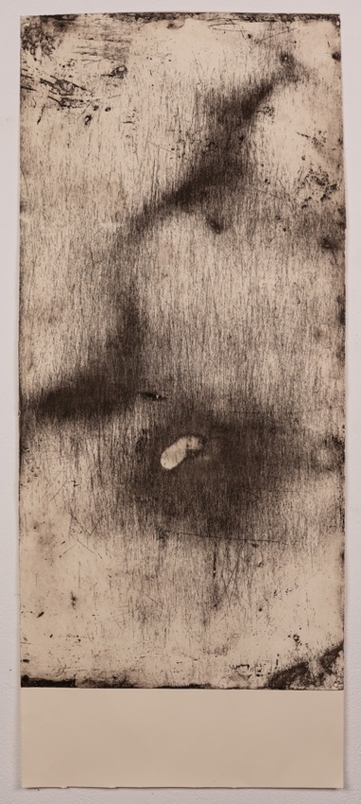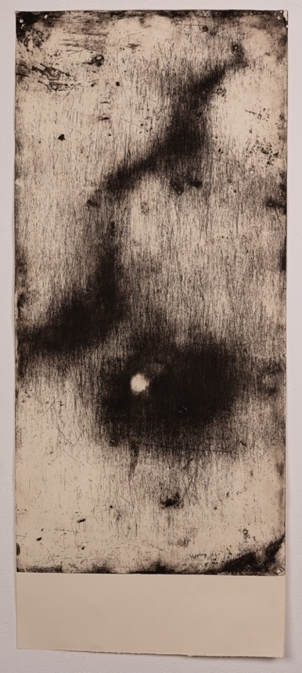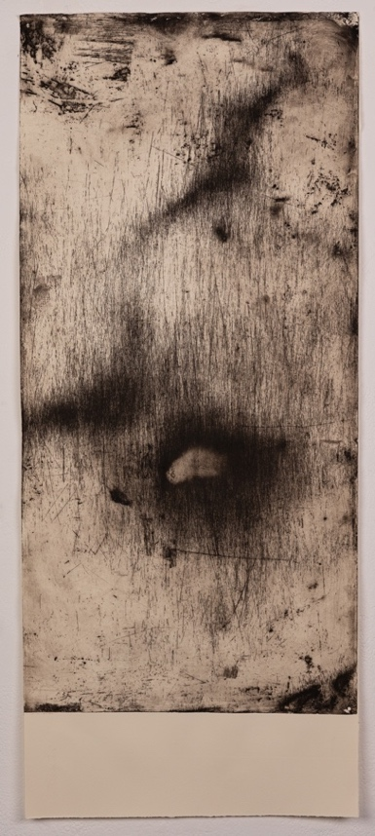
Walk 1 Walk 2 Walk 3
Brendan cooper (Studio 4) “I Walk Therefor I am” 2026 Summerset
printmaking paper 280gsm Size 1020 mm by 430 mm

At this stage I had begun to consider my idea of artist books I wanted a way of recording the walk undertaken for this project in text yet retaining it form as an image as well. After some thought I created two book one large for recording the walk I had done in studio 4 and a smaller book as an instruction guide for anyone who would want to experience the way I created Studio 3,4 (Lost in a Maze and I walk therefore I am).

This final question as discussed above has emerged as the most crucial, as it underlines much of my conceptual farmwork and despite being singular, seeks to address all three questions collectively.

By conceiving the city as both maze and labyrinth—simultaneously disorienting and resistant, yet saturated with possible routes --- the work captures the experience of the contemporary city and the diverse ways one might move through it. This is particularly evident in Melbourne, with its intricate networks of alleyways, laneways and unexpected dead end.

Yet the city only becomes a maze when its pathways appear to be freely chosen. Its Stone, steel and concrete rise up to block the horizon line, while restricting vision as it presses the body forward and cultivating the sensation that no other path exists but the one directly ahead, holding the inhabitant within a “false antinomy of freedom and necessity.

The question becomes: how do I give this tension a visual form?
My practise to date has investigated trace, mapping, erasure and departure across expanded printmaking, performance, and installation. I am now seeking to extend this inquiry into three dimensions, requiring the conceptual framework of my performance practice to be rearticulated through sculpture form, movement and embodied presence.

During the second half of studio 2 I initiated a series of experiments that involved mapping my walking routes with the paintbrush tool in Word. The onset of COVID interrupted the development of this work, leaving it in a provisional state as a sequence of line tracings reminiscent of contour drawing. These tentative, liner arrangements later served as models for the walking path along which I dragged the copper plates. Although incomplete, this earlier project continues to operate as a significant precursor to the finial work.
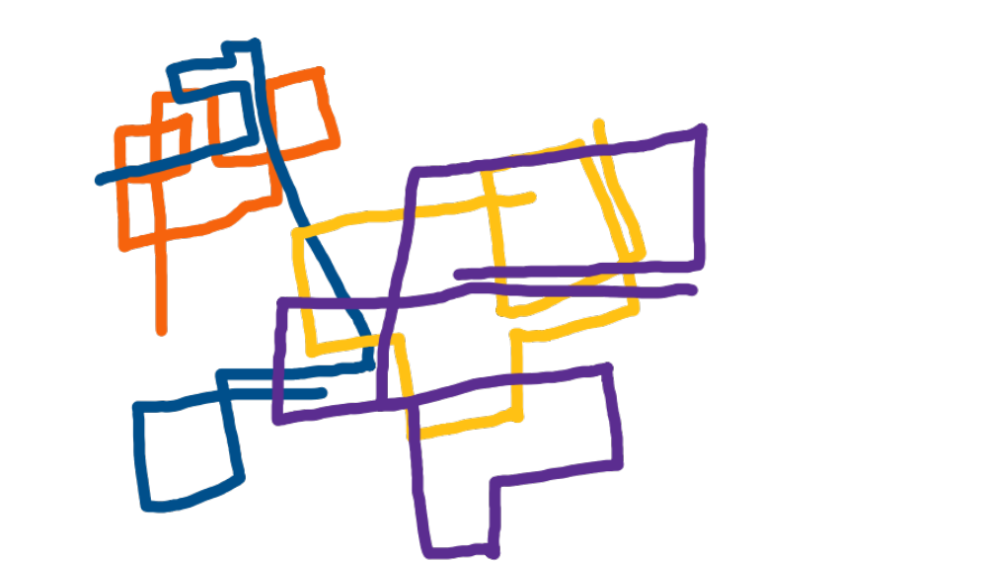
Mapping using paint brush in Word
Brendan Cooper The streets of have walked 2020 30 cm photo copy paper
Many different artists have written, drawn and sculpted versions of labyrinths and mazes. Jorge Luis Borges produced a collection of short stories on the subject, titled labyrinth Tim Ingold, by contrast, distinguishes between the maze and the labyrinth, and then develops this distinction as a conceptual metaphor, suggesting that the city itself can be understood as a maze and Rebecka Solnit’s Wanderlust a history of walking traces the ways in which the basic bodily cadence of walking has informed human cognition, fuelled social change, and redefined our relationship to public space.

“Whether over or underground, whether navigating, the streets or the metro urban pedestrians have to negotiate a maze of passages flanked by walls or high buildings. once set on a particular throughfare they have no alternative, but to continue along it, since it is walled in on either side”.

What all these experiences share is the sense that walking – in both rural and urban environments – is fundamentally bound to being human. We cannot help but walk, whatever the reason, and in many ways the reason itself becomes one of the most vital elements.

This understanding underpins my master’s project on the art of walking as I was retraced the routes my friend Justas once walked, I realised that the copper plate and I were doing more than simply mapping and recording these journeys – and occasionally losing their narrative.

The plate itself was being woven and integrated into the story of the walks. This understanding led me to cut the copper plate and reconfigure it as a maze, both a s a metaphor and a sculptural reflection of the city I had moved through. Arriving at this idea I began to cut the copper on a guillotine in long strips varying in different widths these were to become the walls, alleyways and dead ends that make up a city. At first, I placed them in the direction I walked lying them out flat giving a bird’s eye view of the city however this was not in line with my practise as a whole both in the writing and the making.

In the project over view I make mention of the difference between the labyrinth and the maze and lean heavy on the idea of the city as being more maze like. As this statement form from Ingold suggest “It offers the wanderer multiple choices on many different paths. however, these must end in a freely chosen dead end, where its walls, stone and concert obstruct the view, causing the person to experience a sense that there is no other way then immediately ahead, trapping the inmate with “false antinomy of freedom and necessity”

subsequently after some thought to this statement, I decided that I should shape the copper strip according to the direction of my walks.

Drawing from the project I walk therefore I am in studio 4, I used a press brake to bend the copper at right angles, translating my walk into a sequence of turns: right from building 49 into Franklin Street, along Swanston Street and left, then on Victoria Street and left again and so on till I had the different walks mapped out in the coper strips . These are the same copper plate used in both project studio 3 and 4 and while cutting it into new shapes, I noticed traces of the original text remained on one side of each piece. These ghosted words introduce elusive hierarch, suggesting layers of time, memory, and movement engraved into the material itself.

Then having done this I constructed a maze out of these strips, a maze where you only view it by squatting down this restricts your viewing of the work as a whole and gives you the illusion of being lost, confused and a stray in the city conceding my research and investigation in walking as an art form.

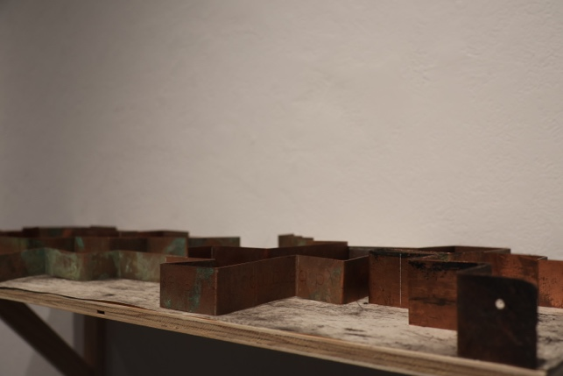 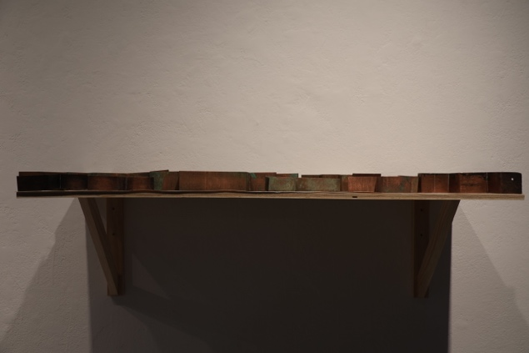Brendan cooper studio 4 NT 2016 copper size 1meter by 44cm

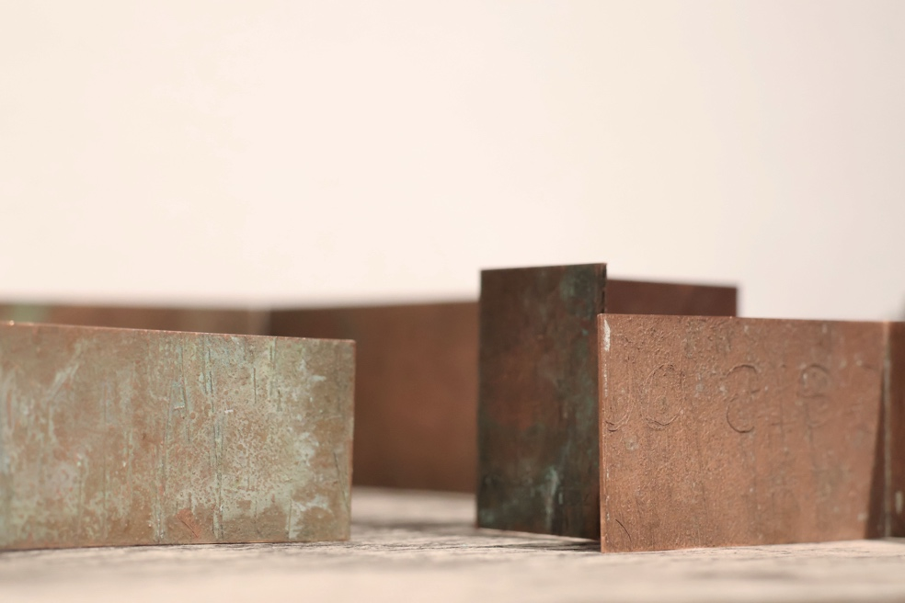

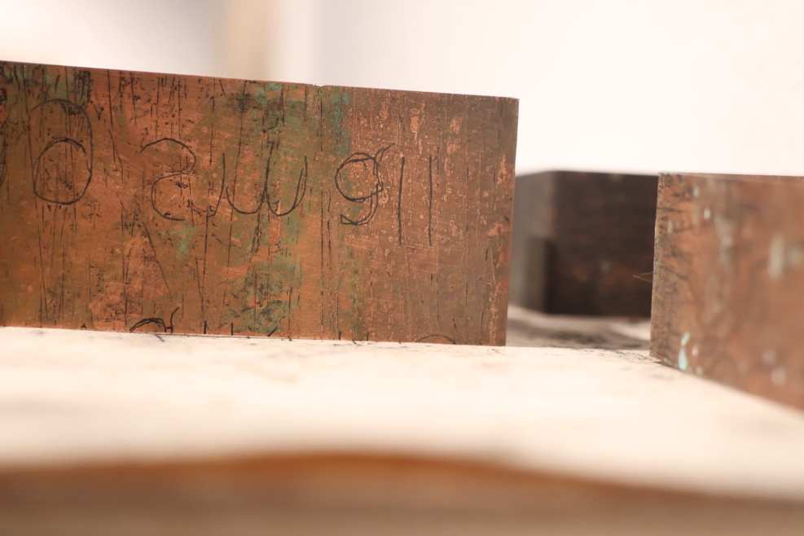

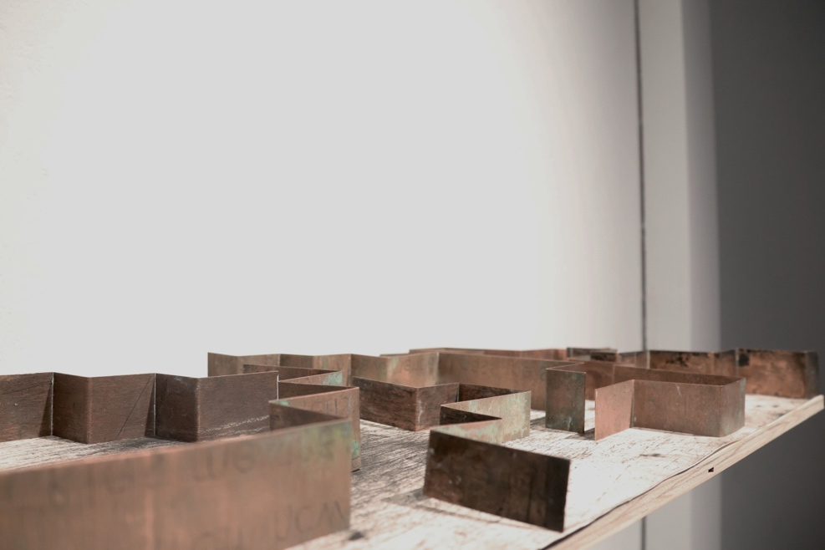 Brendan Cooper NT several copper plates arranged on a print in the form of a maze size 1 meter by 440 cm

Bibliography

Ballard, J. G. High- Rise. Fourth Estate, 2014.

Borges, Jorge Luis. “The Garden of forking paths” In Labyrinths: Selected Stories and other writings new directions.1964. 55

Bourgeois, L. Ode A’ l Oubli. MONA (Web Site) Accessed June 10, 2026. https://www.moma.org/collection/works/98531

Cardiff, Janet. Walk on: from Richard Long to Janet Cardiff. Sunderland, UK: University of Sunderland Learning Development services. 2013.

Careri, Francesco. Walkscapes walking as an aesthetic practice. Culicidae Architectural press.2002.

Davis, Cynthia. retrieved.9/6/26 from Google
https://www.cynthiacdavis.com/artist-books#1

Evans, David. The art of walking: a field guide. Black Dog Publishing. 2012

Huxley, L. This Timeless Moment, A Personal
View of Aldous Huxley. Celestial Arts, Millbrae,
California, 1968.

Ingold, Tim. Lines. Routledge Classics, 2016.

Janet, Cardiff. Walk on from Richard Long to Janet Cardiff. (University of Southerland learning Development services 2013).9

Solnit, Rebecca. Wanderlust: A history of walking. Penguin. 2007

Solnit, Rebecca. Wanderlust: Actions, Traces, Journeys. MIT Press. 2017

Tolkien, J. R. R., Chuck Dixon, and David Wenzel. The Hobbit. Del Rey trade paperback ed. New York: Del Rey, 2012.

Tim Ingold, Lines (Routledge Classics, 2015),
Text generated using Val, Jun 3,2026, RMIT, MFA https://val.rmit.edu.au/c/4455314e-2ed1-478d-87b2-24f53fa3a64b
Rebecca Solnit, Wanderlust: Actions, Traces, Journeys (Cambridge, MA: MIT Press, 2017.
Walter Benjamin, berlin childhood around 1900. (Cambridge Belknap press of Harvard University press, 2006.
Walter Benjamin, Berlin childhood Around 1900. (Cambridge Belknap press of Harvard University press, 2006.
Text generated using Val, Jun 3,2026, RMIT, MFA https://val.rmit.edu.au/c/85c50e46-3ee6-4273-aa9d-ef7ae1b256cb
Text generated using Val, Jun 3,2026, RMIT, MFA https://val.rmit.edu.au/c/fb130dc4-141d-4479-9868-966852d2fcba
Tim Ingold, Lines (Routledge Classics, 2016), 64.
Rebecca Solnit, Wanderlust: Actions, Traces, Journeys (Cambridge, MA: MIT Press, 2017).
Text generated using Val, Jun 3,2026, RMIT, MFA https://val.rmit.edu.au/c/743bb4c5-7d94-4308-8847-a14072ea7da5
Text generated using Val, Jun 3,2026, RMIT, MFA https://val.rmit.edu.au/c/26614838-4aa8-40f4-8106-b42ba048fe71
Text generated using Val, Jun 3,2026, RMIT, MFA https://val.rmit.edu.au/c/9751105a-9bc1-45b2-a61f-01d261c5dc52
Text generated using Val, Jun 3,2026, RMIT, MFA https://val.rmit.edu.au/c/d3d0d114-17ee-47da-aed1-23db17d7bab4
Rebecca, Solnit. Wanderlust: A history of walking. (New York: Penguin, 2000),14.
Rebecca, Solnit. Wanderlust: A history of walking. (New York: Penguin, 2000).
Text generated using Val, Jun 3,2026, RMIT, MFA https://val.rmit.edu.au/c/a2d22b0b-20b5-4fc1-8291-d91147ad6da6
Jean-Jacques Rousseau, Confessions, (1964) quoted in, (Rebecca Solnit. Wanderlust: A history of walking). Penguin. 2000, 14.
Tim Ingold, Lines (Routledge Classics, 2015), 64.
Tim Ingold, Lines (Routledge Classics, 2015), 64.
Text generated using Val, Jun 3,2026, RMIT, MFA https://val.rmit.edu.au/c/ae8d4828-a4df-431a-bcbd-9426a8b02d2f
Text generated using Val, Jun 3,2026, RMIT, MFA https://val.rmit.edu.au/c/a4b94044-2c41-44f3-ae62-f744f13b6da8

